Philip Pearlstein
New Work
February 21– March 30, 2013
Opening Reception: Thursday, February 21st 6 – 8 PM

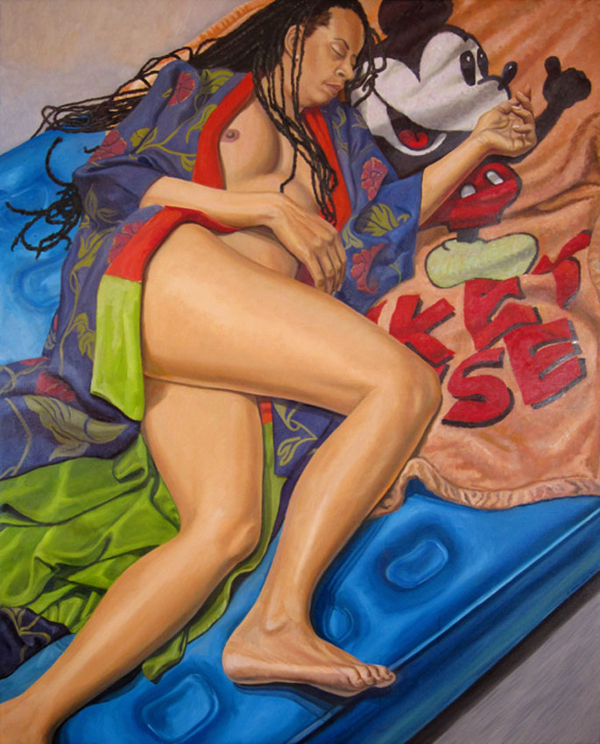
Betty Cuningham Gallery is pleased to announce an exhibition of recent paintings by Philip Pearlstein. The exhibition, the artist’s sixth show at the gallery, will include approximately 10 paintings and 5 watercolors dating from 2011 to the present. Pearlstein will be present for an opening reception on February 21, 6-8pm.
Model on Air Mattress with Mickey Mouse Blanket, 2012, Oil on Canvas, 60 x 48 in.

This most recent body of work continues Pearlstein’s distinct approach to realism. Since 1960 he has studied and painted the oddly ever-changing shape of the nude model, focusing on the technical characteristics of painting the figure rather than creating a storyline.

Around 1982, when he moved into a larger studio, the objects he had collected over the years entered into his view and resulted in more complex compositions. The collectibles ranged from toys to antiquities, Americana-themed novelties to African art. Similar to his models, each object is one element of an overall abstract painting, which has characterized Pearlstein’s canvases for decades. With all storyline removed, the composition and technicality of the painting quickly become the subject. In 2001, Desiree Alvarez, an artist and long time model for Pearlstein, wrote:

The tension in his work comes from the fact that we are not accustomed to perceiving the body as a territory for abstraction. We want a painting of the body to be visceral because our experience of our bodies is visceral. Therefore, we do not bring the language of abstraction, and especially not geometric abstraction, to nude figure painting. Pearlstein’s challenge is that we should.

Pearlstein’s work can be seen in a host of prestigious collections, most notably: The Art Institute of Chicago, Chicago, IL; The Cleveland Museum of Art, Cleveland, OH; Corcoran Gallery of Art, Washington, DC; de Young Museum, San Francisco, CA; Hirshhorn Museum, Washington, DC; Metropolitan Museum of Art, New York, NY; Museum of Fine Arts, Boston, MA; Museum of Fine Arts, Houston, TX; The Museum of Modern Art, New York, NY; National Gallery of Art, Washington, DC; Philadelphia Museum of Art, Philadelphia, PA; and The Whitney Museum of American Art, New York, NY.

Philip Pearlstein was born in Pittsburgh, PA in 1924. He received a BFA from Carnegie Institute of Technology in 1949 and an MA from NYU’s Institute of Fine Arts in 1955. That same year he had his first solo show at Tanager Gallery. Throughout his career, he has held posts as teacher and critic at various institutions, including Pratt Institute, Yale University, and Brooklyn College. From 2003 – 2006, Pearlstein served as the President of the American Academy of Arts and Letters. He lives and works in New York City.

A solo show of Pearlstein’s work, Philip Pearlstein’s People, Places and Things, is set to open in March 2013 at the Museum of Fine Arts, St. Petersburg, FL. His work will also be included in a group show, entitled Skin, at the Royal Hibernian Academy in Dublin, Ireland opening later this year.

For further information, artist biography and/or images, please contact the gallery.
Listing Information: Betty Cuningham Gallery is located at 541 W. 25th St, New York, New York 10001
T: 212-242-2772 F: 212-242-5959 E: info@bettycuninghamgallery.com W: www.bettycuninghamgallery.com
Public Transportation: C or E train to 23rd St.
Gallery Hours: Tues – Sat, 10am – 6pm.
Next Exhibition: Judy Glantzman, April 24 – May 11, 2013

